FY 1997-1998

Aid to Families with Dependent Children/
Temporary Assistance for Needy Families Program
Welfare Reform. Assembly Bill 1542 (Ducheny, Ashburn, Thompson, and Maddy) creates the California Work Opportunity and Responsibility to Kids (CalWORKs) program and creates and modifies other related programs. This act, in conjunction with budget legislation, results in a state cost of $217 million in 1997-98, compared to prior law. This includes $111 million from the Proposition 98 allocation for schools and community colleges. (We note that because of declining caseloads, the budget appropriation for the Aid to Families with Dependent Children/CalWORKs Program is less than estimated expenditures for 1996-97.) Figure 2 provides detail on this fiscal impact and Figure 3 describes the major features of AB 1542.
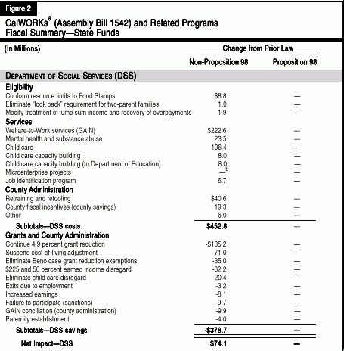
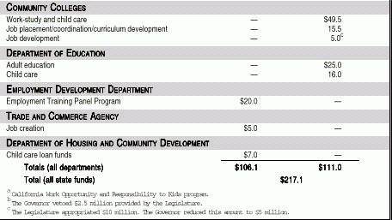

Figure 3
CalWORKsª (Assembly Bill 1542)
Major Features

Eligibility
- "Look Back" Provision. Eliminates the requirement that two-parent families applying for assistance have a prior connection to the labor force.
- Resource Limits. Conforms resource limits to the amounts permitted under federal law for the Food Stamps program. (This increases the asset limit for automobiles, as applied to applicants, from $1,500 to $4,650.)
- Diversion Program. Permits counties to provide eligible applicant families with up to three months of aid payments in the form of a lump sum, for purposes of providing temporary assistance so that the family does not enter the program.

Grants
- Maximum Grants. Continues 4.9 percent statewide grant reduction and suspension of the statutory cost-of-living adjustment through October 31, 1998.
- Beno Exemptions. Eliminates Beno court case grant reduction exemptions (applicable to certain recipients not able to work).
- Income Disregards. Replaces the existing "fill the gap" and "$30 and one-third disregard" with a $225 plus 50 percent earned income disregard, whereby the first $225 of earnings plus 50 percent of each additional dollar of earnings are disregarded in determining the family's grant.

Services
- Welfare-to-Work Activities. Specifies the following sequence of services: job search; assessment; welfare-to-work activities (education and training); and community service employment.
- Child Care. Creates a new delivery system administered by county welfare departments and the state Department of Education.
- Employment Retention. Authorizes up to one year of case management and other job retention services for persons leaving aid due to employment.

Participation Requirements
- Weekly Hours. Adults in single-parent families must participate in work or approved education or training activities for 20 hours per week effective January 1, 1998, 26 hours effective July 1, 1998, and 32 hours effective July 1, 1999 and thereafter. An adult recipient in a two-parent family must participate for 35 hours per week.
- Exemptions. Disabled, elderly, specified caretaker relatives, caretaker of disabled person, teen parent in school, parent with child six months or under (with county discretion to change to 3-12 months). Temporary deferral for "good cause."
- Sanctions. The sanction for failure to participate in work activities or community service is removal of the adult portion of the grant.

Time Limits
- Welfare-to-Work Services. New applicants are limited to 18 months of job training/education services. Existing recipients are limited to 24 months. Counties may extend the 18 month limit by six months if the extension is likely to lead to nonsubsidized employment or if no jobs are available. Able-bodied adults must commence community service employment (work for grant) at the end of these time limits, if the county certifies that a nonsubsidized job is not available.
- Five-Year Time Limit/Safety Net. After five cumulative years on aid, the amount of the grant is reduced by the portion for the adult. The child's portion of the grant would be continued, but counties have the option of providing this aid in the form of cash or vouchers. Certain recipients are exempt, including specified caretaker relatives and disabled persons.

County Administration
- County Training. Provides funding for county training and "retooling."
- County Fiscal Incentives. Provides 100 percent of certain grant savings to the counties. Specifically, allocates 75 percent of the state's grant savings resulting from (1) program exits due to employment lasting six months, (2) increased earnings and (3) diversion of applicants from the program. The remaining 25 percent of grant savings shall be allocated to counties that have not achieved savings but have performed in a manner "worthy of recognition." Counties must use these savings in the CalWORKsª program unless expenditure of these funds is not needed to meet the federal TANF^{b} maintenance-of-effort requirement.
- Fraud Savings. Reallocates 25 percent of the state's savings from fraud detection activities to the counties.
ª California Work Opportunity and Responsibility to Kids program.
^{b} Temporary Assistance for Needy Families.

Supplemental Security Income/State Supplementary Program
Grant Payments. Pursuant to current law, the budget rejected the Governor's proposal to make permanent the 4.9 percent statewide grant reduction enacted in 1995. The budget legislation, however, extends the suspension of the statutory cost-of-living adjustment for one year, resulting in General Fund savings of $27 million.
Elderly Noncitizens. Federal welfare reform, as amended by the Balanced Budget Act of 1997, makes elderly legal noncitizens, who were in the United States prior to August 22, 1996 but not yet receiving aid, ineligible for the Supplemental Security Income/State Supplementary Program. The budget, as passed by the Legislature, provided state-only funded benefits for such legal noncitizens, resulting in a General Fund cost of $17 million in 1997-98. Subsequently, the Governor vetoed these funds.

Food Stamps Program
State-Only Program for Children and Elderly Noncitizens. Federal welfare reform makes legal noncitizens (with certain exceptions) ineligible for food stamps benefits. The budget legislation provides state-only funded food stamp benefits for noncitizens under the age of 18 or over the age of 64. This temporary program commences on September 1, 1997 and sunsets on July 1, 2000.
Prepared by the Health and Social Services Section—(916) 445-6061

