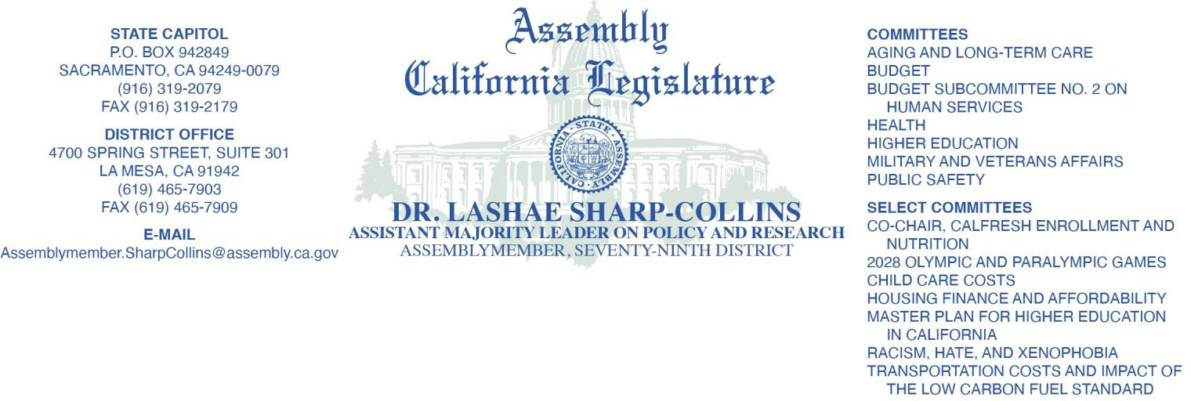

March 12th, 2026

Dear Executive Directors of Legal Aid Programs,
I am writing to invite information and feedback from representatives of California’s Legal Services Corporations (LSC) funded programs for Assembly Bill (AB) 1755 that impacts low-income Californians.

The information provided can either be in writing, placed in the legislative bill portal, or in oral form, and it should be shared with my immediate office and any Senator, Assemblymember, or any Committee Staff that AB 1755 is referred to. You are also invited to testify before any committee that AB 1755 is heard and accepting testimony.
We understand that the LSC-funded programs in California are: Bay Area Legal Aid
California Indian Legal Services California Rural Legal Assistance, Inc. Central California Legal Services Greater Bakersfield Legal Assistance Inland County Legal Services
Legal Aid Foundation of Los Angeles Legal Aid Society of Orange County Legal Aid Society of San Diego, Inc. Legal Services of Northern California,
Neighborhood Legal Services of Los Angeles

Thank you for providing important information on AB 1755. Sincerely,
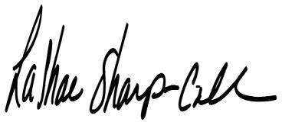

Dr. LaShae Sharp-Collins Assembly Member, 79th District

