Genevieve Richardson, Bay Area Legal Aid, grichardson@baylegal.org
Dorothy Alther, California Indian Legal Services, dalther@calindian.org
Jose Padilla, California Rural Legal Assistance, Inc., jpadilla@crla.org
Patience Milrod, Central California Legal Services, pmilrod@centralcallegal.org
Estela Casas, Greater Bakersfield Legal Assistance, ecasas@gbla.org
Darrell Moore, Inland Counties Legal Services, dmoore@icls.org
Silvia Argueta, Legal Aid Foundation of Los Angeles, sargueta@lafla.org
Kate Marr, Legal Aid Society of Orange County, kmarr@legal-aid.com
Greg Knoll, Legal Aid Society of San Diego, Inc., gek@lassd.org
Gary Smith, Legal Services of Northern California, gsmith@lsnc.net
Neal Dudovitz, Neighborhood Legal Services of Los Angeles, ndudovitz@nlsla.org

Re: Invitation to Legal Service Organizations to Participate in the Legislative Process for AB 396

Dear Executive Directors of legal aid programs:

I am writing to invite information and feed-back from representatives of California's Legal Services Corporations (LSC) funded programs for AB 396 that impact low-income Californians.

The information provided can either be in writing or in oral form, and it should be shared with my immediate office and any Senate or Assembly Committees that AB 396 is referred to. My office and the Senate or Assembly committees that AB 396 is referred to may share this information with other legislators, their staff, committees, agencies, and the executive branch as we deem appropriate.

We understand that the LSC-funded programs in California are:

Bay Area Legal Aid
California Indian Legal Services
California Rural Legal Assistance, Inc.
Central California Legal Services
Greater Bakersfield Legal Assistance
Inland County Legal Services
Legal Aid Foundation of Los Angeles
Legal Aid Society of Orange County
Legal Aid Society of San Diego, Inc.
Legal Services of Northern California
Neighborhood Legal Services of Los Angeles

Thank you for providing important information on the AB 396.
Sincerely,

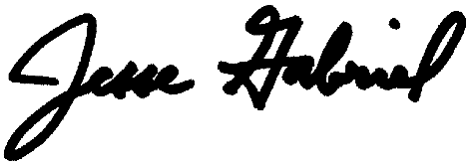

Jesse Gabriel
Majority Whip
Assemblymember, 45th District
California State Assembly

