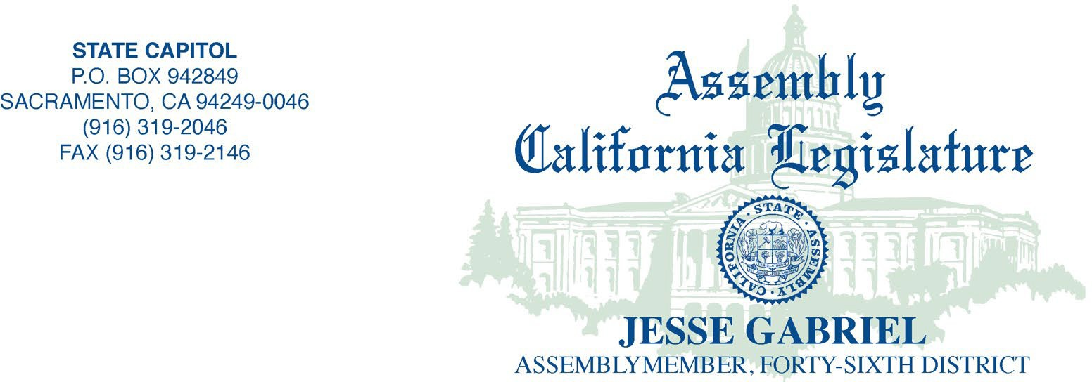

January 7, 2026

Genevieve Richardson, Bay Area Legal Aid, grichardson@baylegal.org Heather Hostler, California Indian Legal Services, hhostler@calindian.org Jessica Jewell, California Rural Legal Assistance, Inc., jjewell@crla.org
Michelle Kezirian, Central California Legal Services, mkezirian@centralcallegal.org Kate Marr, Community Legal Aid SoCal, kmarr@clsocal.org
Valentin Narvaez, Greater Bakersfield Legal Assistance, vnarvaez@gbla.org Tessie Solorzano, Inland Counties Legal Services, tsolorzano@icls.org Silvia Argueta, Legal Aid Foundation of Los Angeles, sargueta@lafla.org Joanne Franciscus, Legal Aid Society of San Diego, Inc., joannef@lassd.org Gary Smith, Legal Services of Northern California, gsmith@lsnc.net
Yvonne Mariajimenez, Neighborhood Legal Services of Los Angeles, ymariajimenez@nlsla.org

Re: Invitation to Legal Service Organizations to Participate in Budget

Dear Executive Directors of legal aid programs:

Please consider this a request from Assemblymember Gabriel that representatives from California's Legal Services Corporation (LSC)-funded programs provide, in written and/or oral form, to my office and members of the budget committee if an invitation to speak at a hearing information and input regarding the state budget. Please submit comment by the online portal when required by the committee.

My office will share the programs’ communication with other legislative staff, committee, agencies and the executive branch as we deem appropriate.

We understand that the LSC-funded programs in California are:

Bay Area Legal Aid Inland County Legal Services California Indian Legal Services Legal Aid Foundation of Los Angeles California Rural Legal Assistance, Inc. Legal Aid Society of San Diego, Inc. Central California Legal Services Legal Services of Northern California
Community Legal Aid SoCal Neighborhood Legal Services of Los Angeles Greater Bakersfield Legal Assistance

Thank you for providing important information on this budget and legislative session. Sincerely,

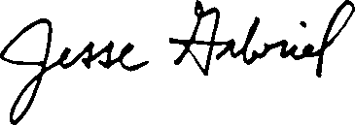

JESSE GABRIEL
Assemblymember, 46th District California State Assembly

cc: Salena Copeland, Legal Aid Association of California, scopeland@laaconline.org

Linda Nguy, Western Center on Law and Poverty, lnguy@wclp.org

