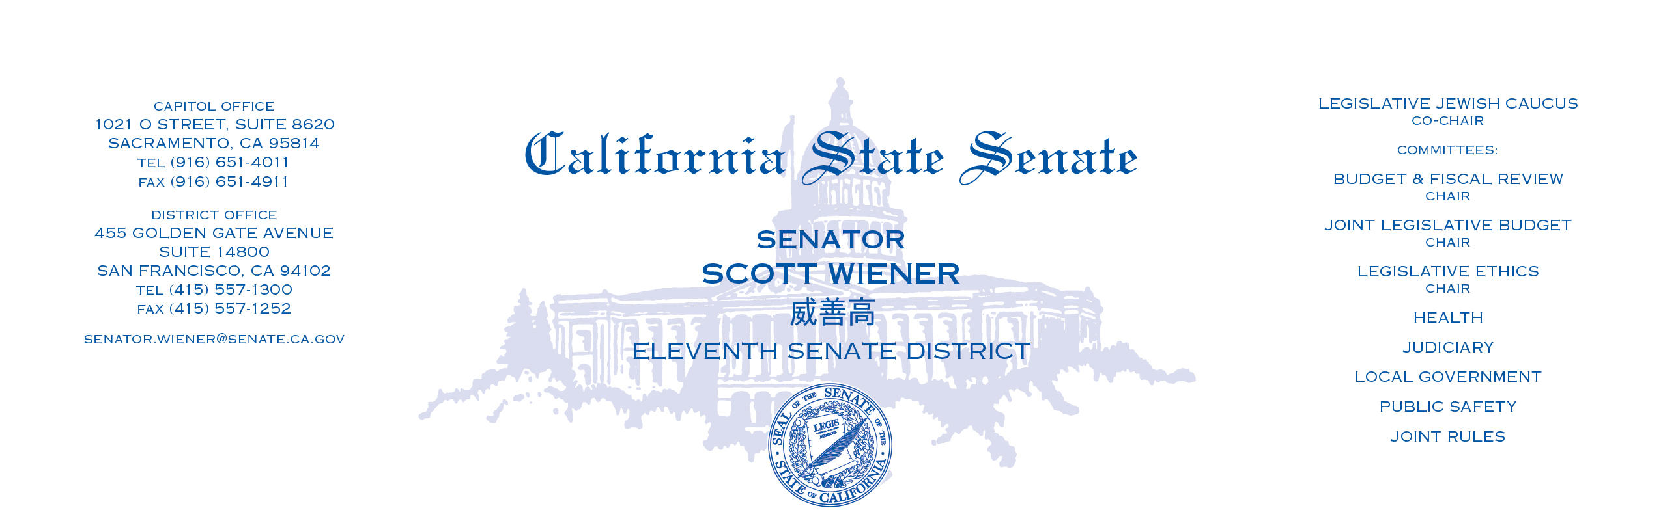

March 21, 2025

Genevieve Richardson
Bay Area Legal Aid

Heather Hostler
California Indian Legal Services

Jessica Jewell
California Rural Legal Assistance, Inc.

Michelle Kezirian
Central California Legal Services

Kate Marr
Community Legal Aid SoCal

Valentin Narvaez
Greater Bakersfield Legal Assistance

Tessie Solorzano
Inland Counties Legal Services

Silvia Argueta
Legal Aid Foundation of Los Angeles

Joanne Franciscus
Legal Aid Society of San Diego, Inc.

Gary Smith
Legal Services of Northern California

Yvonne Mariajimenez
Neighborhood Legal Services of Los Angeles

Re: Invitation to Legal Service Organizations to Participate in Budget

Dear Executive Directors of Legal Aid programs:

Please consider this an official request that representatives from California’s Legal Services Corporations (LSC) – funded programs provide, in written and/or oral form, to my office information and input regarding the 2025-26 Budget.

The information provided can either be in writing or in oral form. My office will share the programs’ communication with other legislative staff, committee, agencies and the executive branch as we deem appropriate.

We understand that the LSC-funded programs in California are:

Bay Area Legal Aid Inland County Legal Services
California Indian Legal Services Legal Aid Foundation of Los Angeles
California Rural Legal Assistance, Inc. Legal Aid Society of San Diego, Inc.
Central California Legal Services Legal Services of Northern California
Community Legal Aid SoCal Neighborhood Legal Services of Los Angeles
Greater Bakersfield Legal Assistance

Thank you for providing important information on this budget and legislative session.

Sincerely,

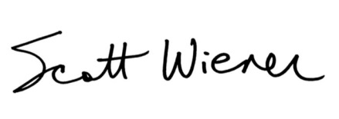
Scott Wiener
Senator, 11th District

cc: Linda Nguy, Western Center on Law and Poverty, LNguy@wclp.org
Salena Copeland, Executive Director, Legal Aid Association of California

