Stateline

States Raid Fund Meant for Needy Families to Pay for Other Programs
STATELINE ARTICLE July 24, 2020
By: Jenni Bergal Topics: Business of Government,Federal Impact,Safety Net & Social Issues
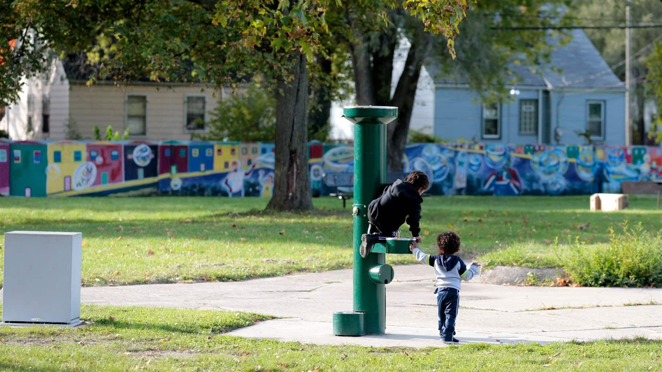
Children play in a Detroit neighborhood last October. Many states are using money meant to help poor families get off welfare on other programs, including pre-K and youth services.Jeff Kowalsky/AFP via Getty Images
Nearly 25 years ago, President Bill Clinton vowed to “end welfare as we know it,” and Congress bought in, passing landmark legislation designed to help millions of low-income Americans find work and get off the rolls for good.
In the early years, the new Temporary Assistance for Needy Families program, known as TANF, which states also must fund, did just that.
But over time, instead of focusing on helping low-income people get jobs, TANF has devolved into a kind of candy store that many states are raiding to plug budget holes and pay for programs that have little to do with moving poor people into the workforce, a Stateline investigation has found.
A review of federal data from 2018, the most recent year available, as well as audits, research reports and state public records revealed that:
- States are directing about 11% of TANF money to work-related activities including education and training. Seventeen states spend less than 5%.
- Some states are playing a paper game in which they’re claiming to meet their own TANF funding obligations by counting donations, services and volunteer hours by nonprofits such as food banks and Boys and Girls Clubs.
- Some states are spending big chunks of TANF money on programs used by families who aren’t in poverty, such as on preschool and college scholarships for middle-class students.
- Many states are using TANF dollars for programs unrelated to work activities, from child welfare to drug courts. Often, those programs already are being paid for by other state agencies, and officials simply count those costs as TANF spending.
- Just 1 in 4 TANF cases close because clients found jobs. Others close because people have lost eligibility, failed to comply with requirements or for other reasons.
“Overall, the states have radically abused the program,” said Robert Rector, a senior research fellow at the conservative Heritage Foundation think tank who helped craft the original law as an adviser to two members of Congress. “Almost every state government has failed to carry out the principal objectives. Promoting work is the key idea of the act and they do virtually nothing — both red and blue states.”
And at a time when tens of millions of Americans have lost their jobs because of the COVID-19 pandemic, it’s going to be tougher than ever for TANF parents to find work that will lift them out of poverty, advocates for low-income families say.
“The people who are struggling in poverty are probably always going to be at the end of the line, when it comes to being hired or rehired,” said Beth Giesting, a director at the Hawaii Appleseed Center for Law and Economic Justice, a nonprofit that advocates for low-income residents. “Many people are going to be affected long term by this pandemic.”

Broad Authority
The federal government gives states a total of $16.5 billion a year in TANF block grants, a number that hasn’t changed since Congress created the program in 1996.
To get their full share of the federal grants, states also must contribute or count as TANF spending a set amount of their own money for benefits and services to needy families. The state dollars are collectively called “maintenance of effort,” known as MOE. In 2018, states overall spent $14.8 billion in MOE, according to data from the U.S. Department of Health and Human Services (HHS).
Congress gave states significant flexibility to decide on cash benefits amounts, eligibility and other requirements. It also allowed states wide latitude on how they can spend TANF dollars, as long as they are used for at least one of four broad purposes: giving assistance to needy families so children can be cared for in their own homes or with relatives, promoting job preparation and work, preventing and reducing out-of-wedlock pregnancies and encouraging two-parent families.
"The spirit of the TANF dollars was not meant for this purpose. But we talked to the feds and we knew it was allowable."
Kurt Weiss, spokesperson MICHIGAN STATE BUDGET OFFICE
To get direct cash payments, clients must be either pregnant or responsible for a child under 19. Eligibility varies from state to state. Work requirements apply only to clients who get cash assistance, and those who are disabled or have a young child may be exempt.
TANF money for cash assistance and work-related activities can be used only for families whom states define as “needy.” But when it comes to the out-of-wedlock and two-parent family goals, states also can use the federal money for families with higher incomes.
That’s one of many loopholes, critics say.
“I don’t think anyone envisioned in 1996 that they were giving states such broad authority on how to spend the money,” said Liz Schott, a senior fellow at the Center on Budget and Policy Priorities, a liberal think tank. “There’s no there there, in the federal law. They ended up saying, ‘Gee, we can use this as a cash cow for all kinds of state aid.’”
In the years following TANF’s launch, lots of clients left the welfare rolls. The economy grew and more people were able to find work. There was more subsidized child care. Some states began making it harder for clients to get TANF by creating tougher eligibility requirements and restrictions.
When the program started in 1996, about 4.4 million families were on welfare. In September 2018, there were about 1.2 million families, including nearly 2.3 million children.
As caseloads declined and states found themselves with surplus TANF money, some started moving it into other child-related social service programs that they said helped keep low-income families together and stable, and protected children from being at risk. By 2018, states overall were using about 14% of their federal and state TANF money for child welfare and pre-K, HHS data shows.
And while they spent 21% on cash assistance to pay for basic expenses such as rent, food and clothing in 2018, nearly a dozen spent less than 10%, according to Center on Budget and Policy Priorities data.
“Pre-K, child welfare, all of these are valuable things, and it’s important that they’re funded,” said Heather Hahn, a senior fellow at the Urban Institute, a think tank in Washington, D.C. “But it shouldn’t come at the expense of not providing basic assistance and work supports for people who need them.”

Spending Controversy
While state TANF programs generally get little public attention, Mississippi’s faced national scrutiny earlier this year.
In February, the Mississippi state auditor’s office arrested the Department of Human Services’ former executive director and five others in a massive, multimillion-dollar TANF fraud scheme that officials said was the largest embezzlement case in state history. A May audit concluded that millions of dollars of TANF grants meant for poor families had been misspent, converted to personal use or used by family members and friends of staffers and grantees.
The defendants, who have pleaded not guilty, allegedly used a variety of business entities and schemes to defraud taxpayers, according to investigators.

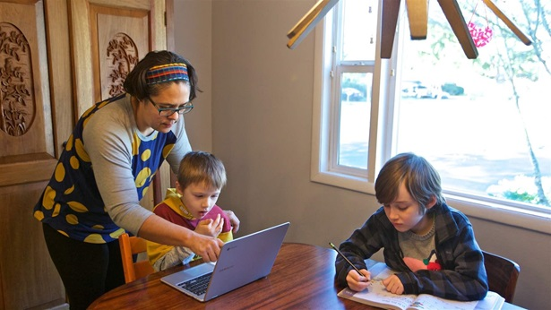
STATELINE STORY May 26, 2020

Single Mothers Hit Hard by Job Losses

Also caught in the controversy was former NFL superstar Brett Favre, who auditors say was paid $1.1 million in TANF money for speaking engagements, promotions and appearances that he did not make in 2017 and 2018. Favre was not charged in the case. He later said he did nothing wrong and that he believes he did perform the work he was asked to do, although he is paying back the money anyway. He said he did not know the payments were coming from a program that was supposed to be for the state’s neediest families.
While the Mississippi case is unusual, critics say it points out the overall lack of TANF oversight.
“Mississippi is an example of how a program with so little oversight can be abused,” the Center on Budget and Policy Priorities’ Schott said. “But what’s really a problem with TANF is all the things that states are doing that are not illegal. One of the biggest problems is the lack of accountability. The feds have no information beyond what the states give them.”
HHS requires states to audit programs that spend $750,000 or more in federal money, including TANF. States also must send the federal agency forms every year that break out TANF spending in general categories and give other basic information. But states don’t have to provide a lot of details about how and where money is being spent.
"There are a whole lot of games states play to undermine the work participation requirement."
Matt Weidinger, fellow AMERICAN ENTERPRISE INSTITUTE
States also must meet certain federal requirements for using their own money. They typically must spend 75% of what they were spending on welfare and related programs prior to TANF to get all their federal dollars. They also must ensure that at least 50% of TANF families with a work-eligible individual be engaged in work activity for a certain number of hours a week. States that don’t meet both requirements can lose federal grant money.
But there’s also a reward for states: If they reduce caseloads or spend more on maintenance of effort than is required — at least on paper — their work participation rate can be reduced and they can keep all their federal dollars.
“There are a whole lot of games states play to undermine the work participation requirement,” said Matt Weidinger, a former U.S. House staffer who is a fellow at the American Enterprise Institute, a conservative think tank.
A 2019 study by Weidinger and Ron Haskins, a senior fellow at the Brookings Institute, a liberal think tank, found that states have “exploited ways to undermine the participation rates” and used loopholes and accounting “tricks” to meet the standard. States should be required to contribute their fair share to TANF instead of diverting funds, they wrote.
Many state TANF departments count spending by other agencies on programs not directly related to TANF and work activities as maintenance of effort. Those include child welfare, domestic violence hotlines, homework help for kids and school learning-assistance programs.
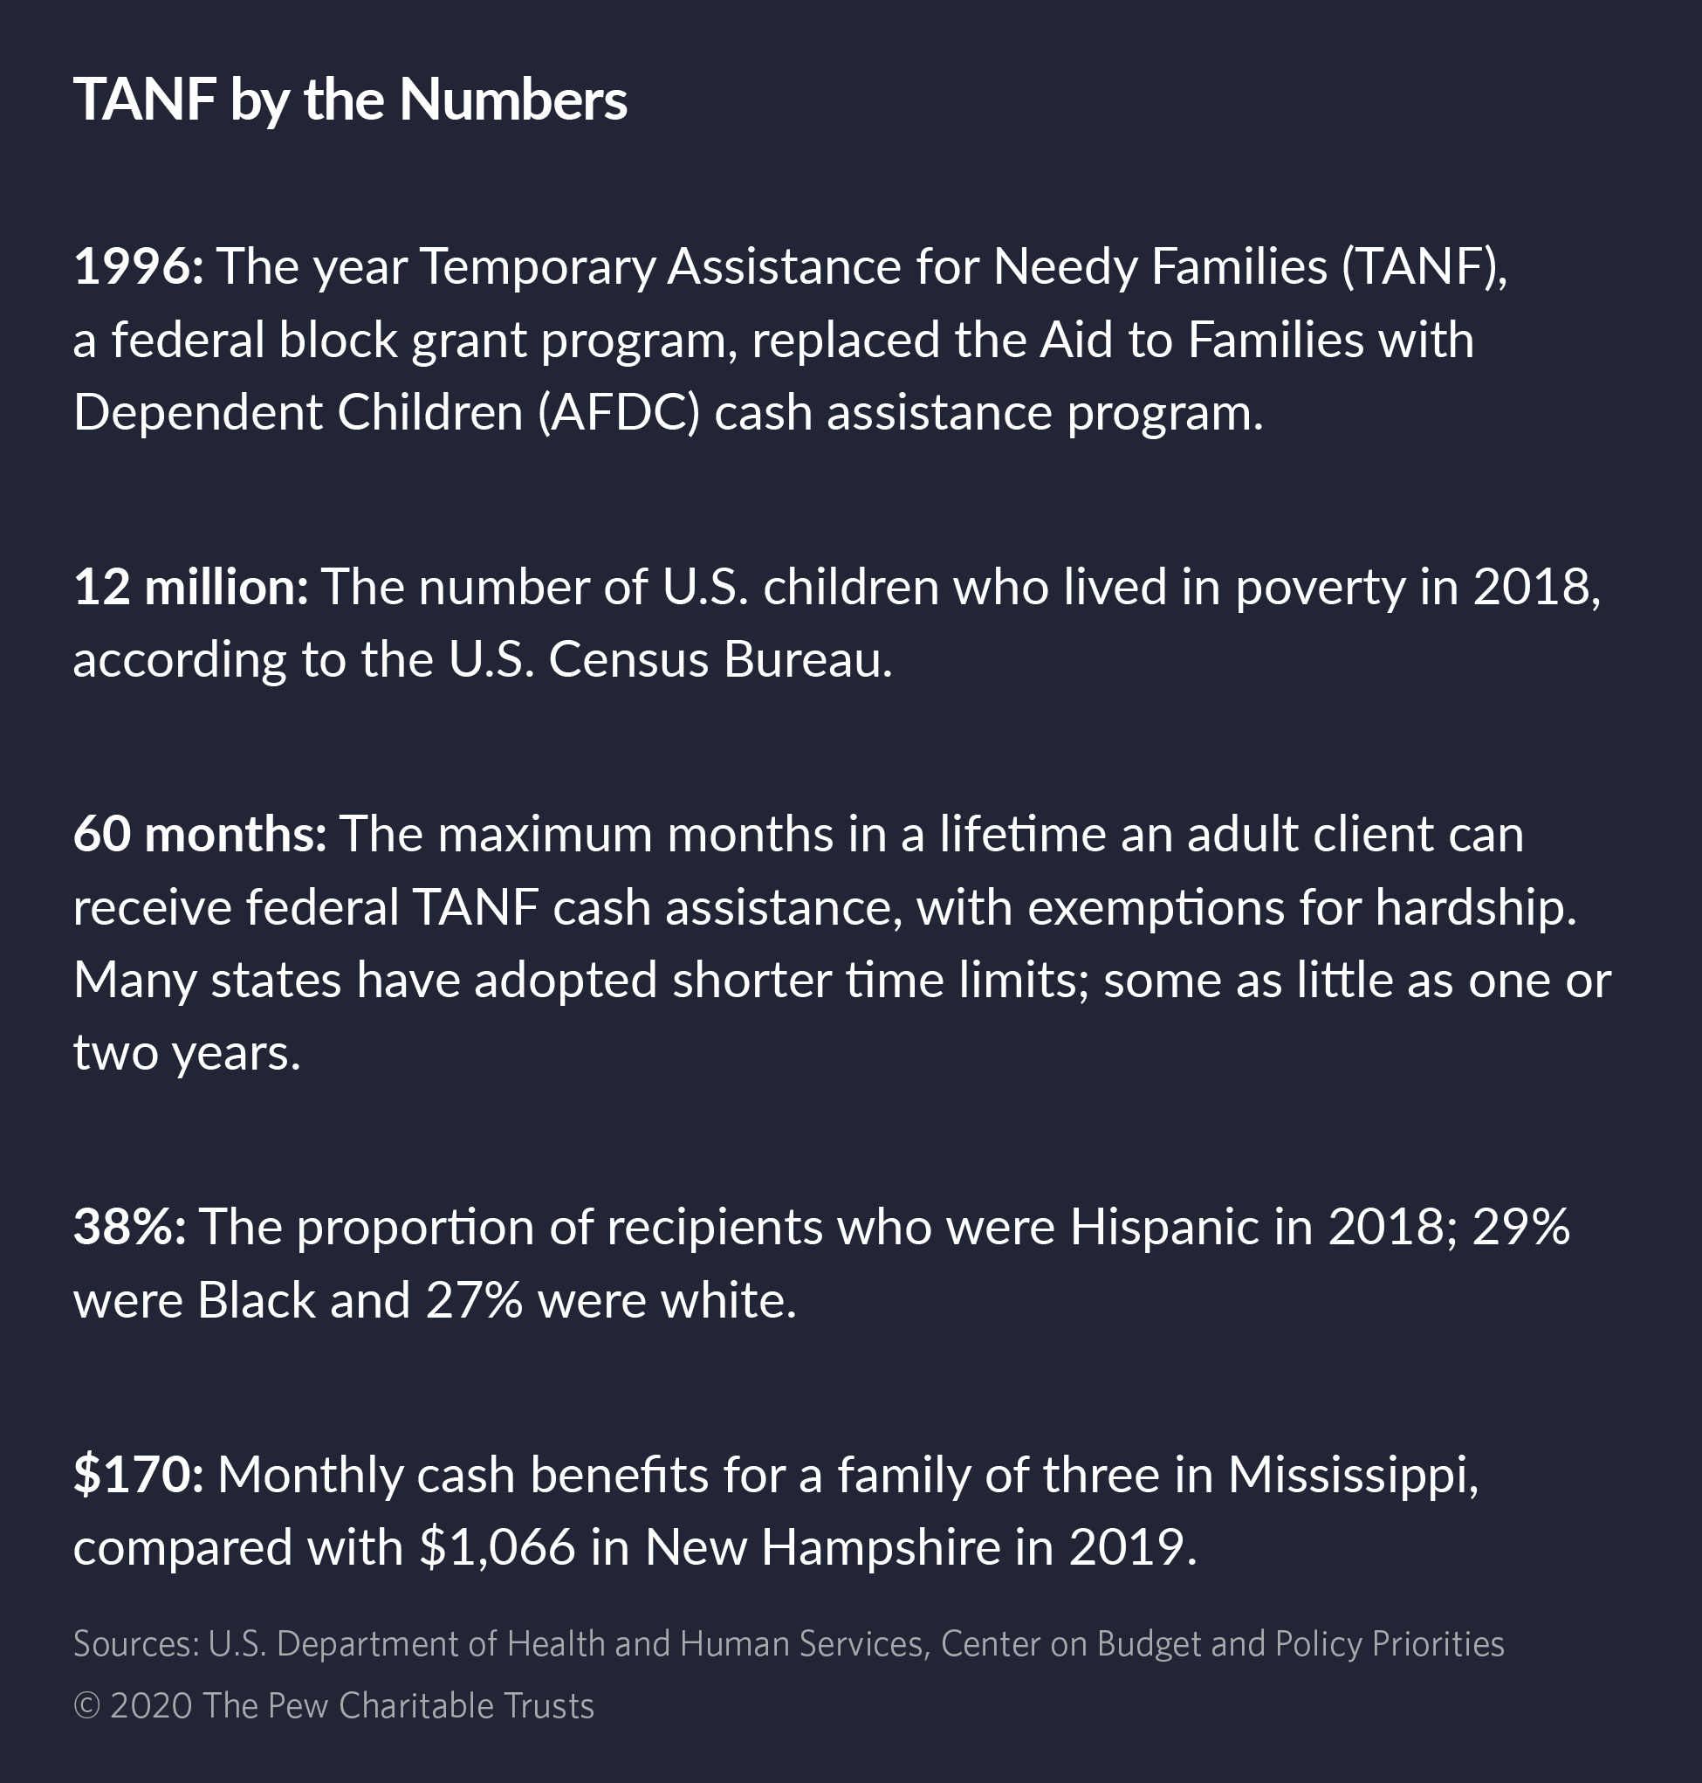
Indiana, for example, counted half of its MOE spending — about $61 million — for a textbook reimbursement rental program for elementary and high school students from low-income families in 2018.
“TANF is a Christmas tree for the states where they can do all kinds of crazy things with the money,” said Kevin Aslanian, executive director of the Coalition of California Welfare Rights Organizations, a nonprofit support center for welfare lawyers. “It doesn’t really address the needs of the clients. This is Temporary Assistance for Needy Families, not needy states.”
In Arizona, nearly two-thirds of the $334 million in federal and state TANF spending in 2018 went to its child welfare system to deal with abused or neglected children, foster care and other services. Just 12.5% went to cash assistance and 2% to work-related activities and support, according to HHS data.
That decision — made by the legislature — angers Democratic state Rep. Mitzi Epstein, who said child welfare programs should be funded through general revenue, not TANF dollars.
“This is a shell game,” Epstein said. “It’s plugging holes in the budget by shifting money from one fund to another. It’s not meeting the purposes of TANF of helping people get a job or get a better job and improve their lives.”
In Louisiana, much of the federal TANF money goes to other state agencies. And almost all the $63 million counted as maintenance of effort is money already being spent by agencies such as the departments of education and corrections.
“TANF is a slush fund,” said Jan Moller, executive director of the Louisiana Budget Project, a nonprofit research and advocacy group. “When Louisiana started having a budget crisis, TANF became a piggy bank that ended up diverting money from the core original goals of welfare reform.”
As of last month, 2,450 families in Louisiana were getting direct TANF cash assistance, which pays $240 a month for a family of three — among the lowest rates in the nation.
"TANF is a Christmas tree for the states where they can do all kinds of crazy things with the money. It doesn’t really address the needs of the clients. This is Temporary Assistance for Needy Families, not needy states."
Kevin Aslanian, executive director COALITION OF CALIFORNIA WELFARE RIGHTS ORGANIZATIONS
Marketa Garner Walters, secretary of Louisiana’s Department of Children and Family Services, said in an interview with Stateline that she would like to see her state distribute TANF money differently and stop using it to pay for programs such as child abuse investigations and a homeless initiative.
“But all these programs have a legislative champion,” she said. “If I go to the commissioner [of the administration] and say, ‘I don’t want to fund drug courts anymore. I want to take that $5 million and spend it differently,’ you can bet the judiciary is going to scream bloody hell and say pick something else.”

College Scholarships
Louisiana also is one of the states that spends or counts chunks of TANF money on college scholarships and financial aid, often for students who aren’t eligible for TANF, whose families may be middle class or even wealthier.
Louisiana counts more than $30 million paid by the Office of Financial Assistance for two scholarship programs as maintenance of effort. One is merit-based and gives students a full scholarship to any public university in Louisiana.
“It’s become this politically sacrosanct entitlement program,” said Moller, of the Louisiana Budget Project. “If you are a poor kid from a poor family who kicks butt in high school, the program is a lifeline. You get your full tuition paid at LSU [Louisiana State University] or any state university. But a doctor’s kid also gets to go to LSU on the exact same scholarship.”
Walters doesn’t support the practice but admits it’s a popular program among legislators, just as it is in other states.
“That has been the political will,” she said. “We haven’t been able to pick any fights against things that were already established. It isn’t anything we’ve had the luxury to attack or try to change.”

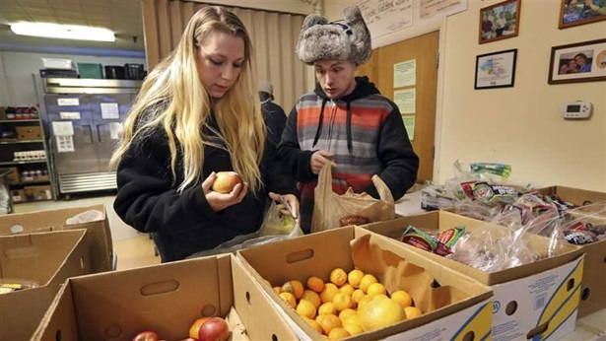
STATELINE STORY January 25, 2018

Where the Work-for-Welfare Movement is Heading

It’s a similar story in Michigan, which spent $103 million in federal TANF money in 2018 on college scholarship programs. One program is geared to students from families who are Medicaid-eligible; the others are available to students from middle-class and more affluent families.
The scholarship issue has been ongoing in the 10 years Kurt Weiss has been a spokesperson for the Michigan State Budget Office, he said.
“We were in a pickle during the Great Recession. The spirit of the TANF dollars was not meant for this purpose,” Weiss said. “But we talked to the feds and we knew it was allowable. So we went ahead and did it because we didn’t have the general fund dollars. You have to make all these crazy, tough decisions.”
Weiss said his office, which works for Democratic Gov. Gretchen Whitmer, had been planning to start pulling TANF dollars out of scholarships in the 2020-21 budget and using them for their intended purpose. “But now that COVID has hit, who knows how the budget is going to shake out,” he said.

Third-Party Spending
Some states satisfy federal requirements by counting as MOE in-kind services or cash expenditures by nongovernmental third parties, often nonprofits such as food banks and Boys and Girls Clubs. The groups typically estimate the value of the services they’ve provided to needy families, as well as cash donations and volunteer hours, and states report that as maintenance of effort spending.
No one currently tracks how much state TANF spending goes to third parties. States aren’t required to break out that information and send it to the federal government.
But in 2016, a report from the U.S. Government Accountability Office found that nearly one-third of states counted third-party spending toward their required TANF spending. Most of the organizations provided food assistance or ran youth programs.
Third-party spending accounted for more than 10% of total MOE spending in about a dozen states, the report found. It was highest in Georgia, at nearly 60%, followed by Alabama at 39% and New Hampshire at 18%.
States defended the practice to auditors, saying it helps develop public-private partnerships and allows states to get credit for reducing their caseload.
But HHS officials who responded to the report said the Obama administration had proposed eliminating the practice. Prohibiting it, they wrote, would “help to ensure that states maintain their commitment to needy families as the law intended.”
Not every state moves large amounts of TANF money to other programs or counts it as third-party spending.
South Dakota, for example, does neither. It spent 46% of its federal and state dollars on cash benefits and another 11% on work-related activities in 2018, according to HHS data.
“We believe in providing opportunities to South Dakota families that help them achieve self-sufficiency,” Laura Ringling, legal services director at the Department of Social Services, wrote in an email. “Our commitment to South Dakota families is reflected in the distribution of TANF funds.”

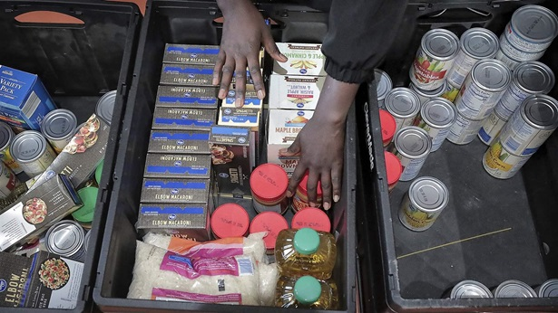
STATELINE STORY November 12, 2019

States Hold Onto Federal Dollars Meant for Needy Families

But some states, such as Georgia, continue to be aggressive about third-party TANF spending.
Georgia considers it “a significant part” of its maintenance of effort, according to Patrice Meadows, a Department of Human Services spokesperson. In 2018, the state counted $40.4 million as third-party MOE, all for children and youth services, such as educational support and parental aides.
And while Georgia invests only 2% of its state and federal TANF dollars on work, education and training activities, it spends 43% on the child welfare system, which is focused on keeping children safe from abuse and neglect.
“State policy makers have been supportive of child welfare services as a safety net for children and families,” Meadows wrote in an email, “but in general our policy makers are not big supporters of high levels of cash assistance.”
TANF has been all but eliminated as a source of cash assistance for people who fall well below the poverty line in Georgia, said Alex Camardelle, a senior analyst at the Georgia Budget and Policy Institute, a nonprofit think tank.
Since TANF began, the number of cases in Georgia has dropped nearly 90%, he said. “The reason isn’t that they’re moving out of poverty,” Camardelle said, “but that we have some of the most draconian work requirements, a strict time limit and a family cap for receiving benefits.”
For those on the TANF rolls, he added, cash assistance is low: A family of three gets $280 a month.
And like many other states, Georgia has chosen to use TANF for things other than payments to clients and job training and employment services aimed at lifting them out of poverty.
“It’s an unfortunate practice that we’ve been fighting for quite some time,” Camardelle said. “It’s literally become one of the notorious ways we’ve balanced our budget. Legislators say, ‘Let’s just take TANF dollars and plug them in here and there.’”

